Lab Session – Day 4

**Question:**

Use classicmodels. Categorize the customers into High, Medium and Low values with respect to creditLimit column as per following conditions.

* High: creditLimit > 100000
* Medium: creditLimit between 25000 and 100000
* Low: creditLimit < 25000

The output should look as shown in below image.

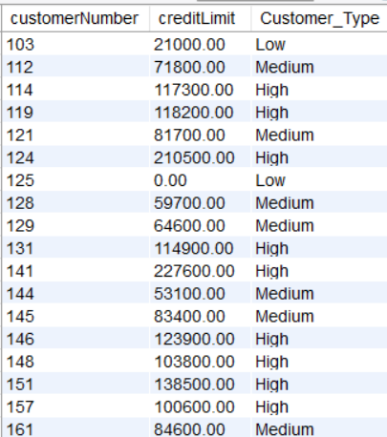

**Solution:**

Write the below query in MySQL workbench.

